
Year 7

Mini Test 2

CHANCE

Total Marks: 23 marks
Name: _____________________ Total Time: 30 minutes

Show working and answers on this sheet. Show working in sufficient detail to support your answers. Incorrect answers without supporting reasoning may be allocated zero marks.
No Resources Allowed

Question 1 2 marks

Match the definition on the left-hand side with the correct word on the right-hand side by drawing a line between each one:

Set of all possible outcomes of that experiment |  | Favourable Outcomes
When a result has a high chance of happening |  | Even Chance
How often something happens (usually during a period of time) |  | Sample Space
An equal likelihood that something will or will not happen |  | Probability
the chance that something will happen - how likely it is that some event will happen |  | Frequencies

Question 2 1 mark

Which term best describes the chance of rolling an odd number on a die? Circle the correct answer.
A impossible B improbable
C even chance D likely

Question 3 1 mark

The probability that it will rain this weekend is 33%. What is the probability that it will not
rain? Circle the correct answer.

A 66% B 77% C 33% D 67%

Question 4 1 mark

A bag contains 15 balls of which 11 are red, the probability of getting a red ball at random from the bag is: (Circle the correct answer)
A $\frac{11}{11}$
B $\frac{15}{11}$
C $\frac{11}{5}$
D $\frac{11}{15}$

Question 5 1 mark

The probability of getting an even number if a card is drawn from a box containing 12 identical cards numbered 1, 2, 3, ......,12 is: (Circle the correct answer)

A $\frac{1}{2}$ B $\frac{1}{5}$ C $\frac{2}{5}$ D None of the above

Question 6 1 mark

A numbered spinner shown below is spun:

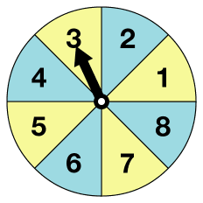

What is the probability of getting a number greater than 5?

A $\frac{1}{2}$ B 1 C $\frac{2}{5}$ D None of the above

Question 7 1 mark

The lowest possible value of a probability is:
A −1 B 0 C 0.1 D 1

Question 8 1 mark

List the sample space of a 6 sided die: (Circle the correct answer)

_______________________________________

Question 9 1 mark

If the spinner is spun, on which number is the arrow least likely to stop?

______________________________________
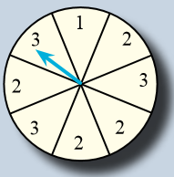

Question 10 2 marks

One coin is tossed:

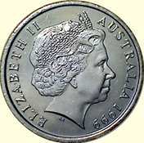

a What is the sample space?

___________________________________
b What is the probability of tossing a Head?

___________________________________
C If I toss the coin one hundred times, how many heads should I get?
________________________________

Question 11 5 marks

An eight-sided die is thrown. The resulting sample space is {1,2,3,4,5,6,7,8}. What is the probability of each of the following?
a 1
_______________________________________

b Odd
_______________________________________

C >4
_______________________________________

d <1
_______________________________________

e 9
_______________________________________

Question 12 6 marks

A class raffle is conducted by writing the numbers from 1 to 25 on a piece of paper and placed in a bag. What is the probability that the drawn number is:
a 15?
____________________________________________________________________________

b Even?
____________________________________________________________________________

c Divisible by 5?
____________________________________________________________________________

